Title: “What can the FIU Libraries do for you?”
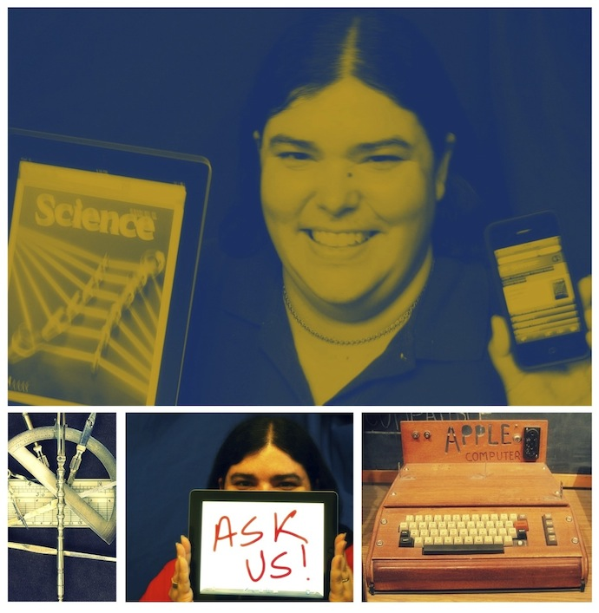
SAVE THE DATE!!! You have been invited to the Electrical and Computer Engineering Seminar Series on Friday, February 14, 2014.
Find details of the presentation below.
When: Friday, February 14, 2014
Time: 10:00 AM - 11:00 AM
Where: FIU Engineering Center, EC 2300
Contact: 305-348-2807
Map: http://campusmaps.fiu.edu/

Speaker: Ms. Patricia Pereira-Pujol
Information Services Librarian for Science & Engineering at FIU’s Green Library

ABSTRACT
The FIU Libraries offer many services and research resources to the FIU community, however many faculty and students are not aware of them. These resources are particularly important to academic programs that are research-intensive. The migration from print to electronic media has made most of these services and resources instantly accessible to faculty and students from any location. In this presentation, Ms. Pereira-Pujol will describe and demonstrate the services and research resources offered by the FIU libraries, especially those most relevant to the Engineering and Computing community. The format of the presentation will be interactive, and those in attendance are encouraged to ask as many questions as time allows.

BIOGRAPHY
Patricia Pereira-Pujol has been the Information Services Librarian for Science & Engineering at Florida International University’s Green Library since 1999, and currently holds the rank of Associate University Librarian. Born and raised in Puerto Rico, Ms. Pereira-Pujol graduated high school on the island and left for the first time to attend college. She received her B.S. from the Massachusetts Institute of Technology in 1991 and her M.L.I.S. from the University of South Florida in 1999.

